FAGLL03H-G/L LINE ITEM BROWSER- FOR IDENTIFYING OPEN ITEMS


This simulation focuses on how to find Open/Cleared items in T-Code FAGLL03H-G/L Line Item Browser.

For general functionalities of FAGLL03H report, please refer to a separate simulation FAGLL03H-General Purpose.

Click to continue.

Explanation | Screenshot
[1] FAGLL03H is now entered in the Transaction box. | 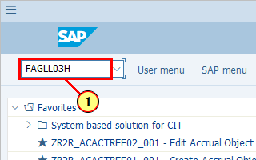
[2] Click Choose Ledger .  You can also press Ctrl+F3. | 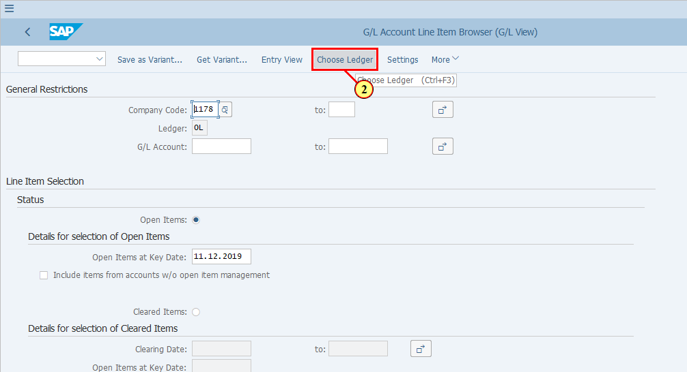
[3] Click next to field Ledger to open the dropdown list for Ledger selection. | 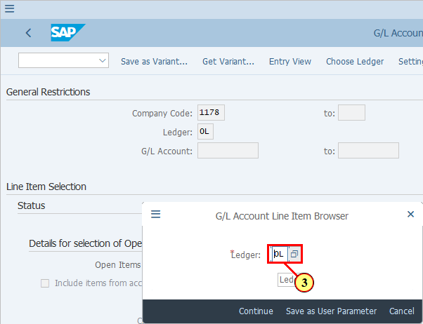
[4] IFRS (Leading) is double-clicked. | 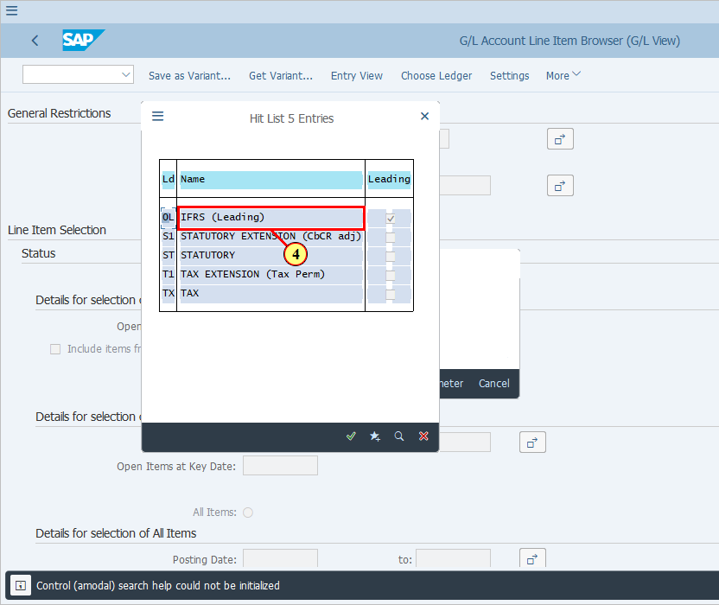
[5] Click Continue .  You can also press Enter. | 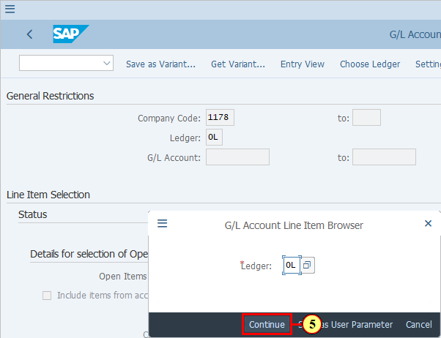
  This is the G/L accounts for which you wish to check Open/Cleared items. So it should be G/L accounts with one the following settings in their G/L Master Data:  - Open Item Management  - Clearing Specific to Ledger Groups  You can of course use a range. In this case the system will display all G/L line items in this account range regardless of these settings. Then you will need to filter for accounts to see specific items in specific accounts.  We will be using a range in this demo.  If you select Open Items, then please indicate a key date for open items as well. | 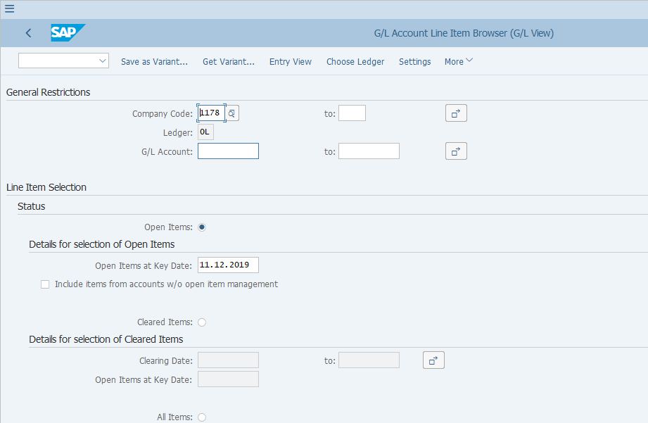
[6] The G/L Account field is filled out. | 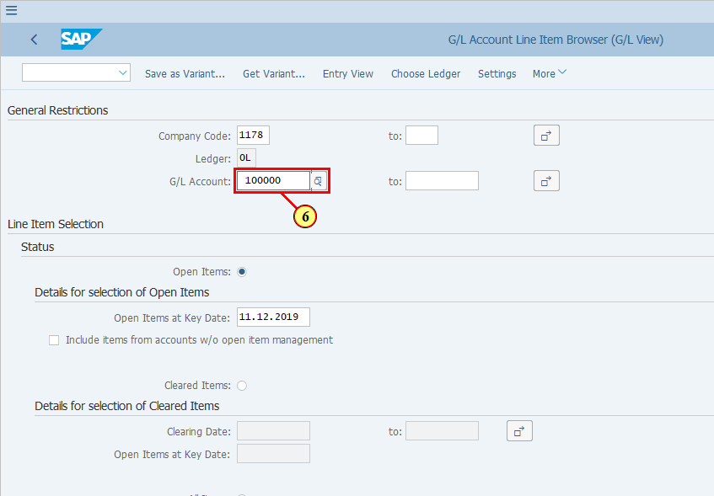
[7] The to field is filled out. | 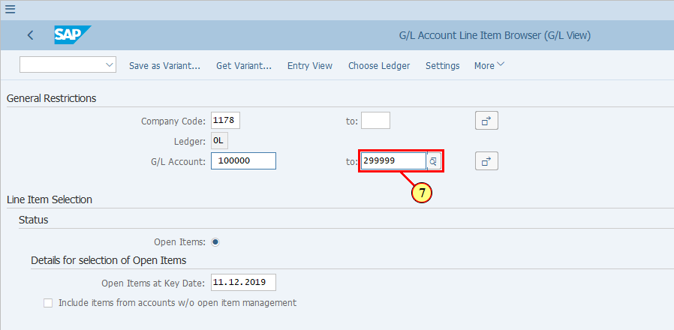
  In FAGLL03H, it is possible to restrict your selection of accounts or line items based on certain master data or transaction data fields.  E.g., if we would like to see only line items for G/L accounts which can be cleared specific to Ledger Groups, or G/L accounts which are set as Open Item Management, we can use Restriction to achieve this. | 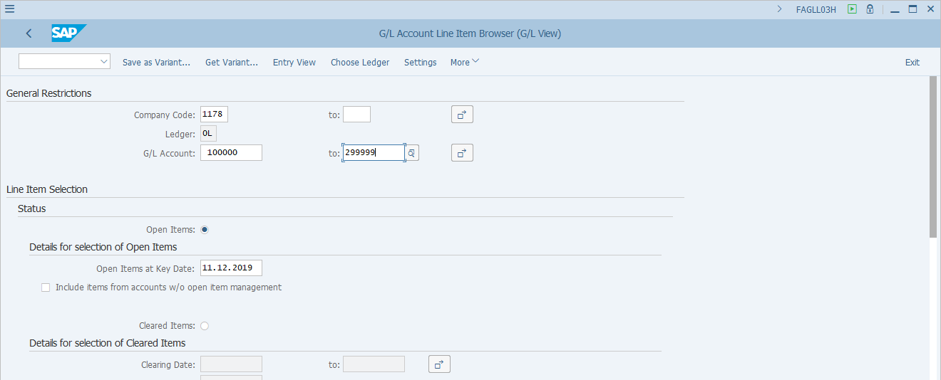
[8] Click Restrictions . | 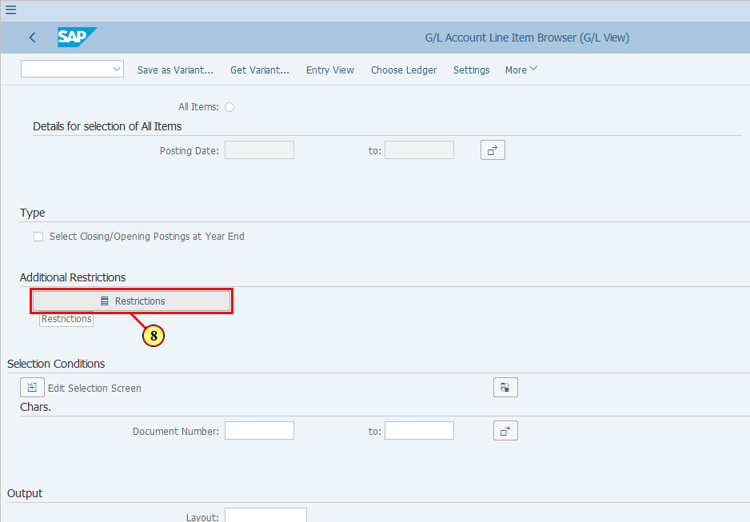
[9] Click on the search icon of the pop up window and enter the search term in the Field Name field. | 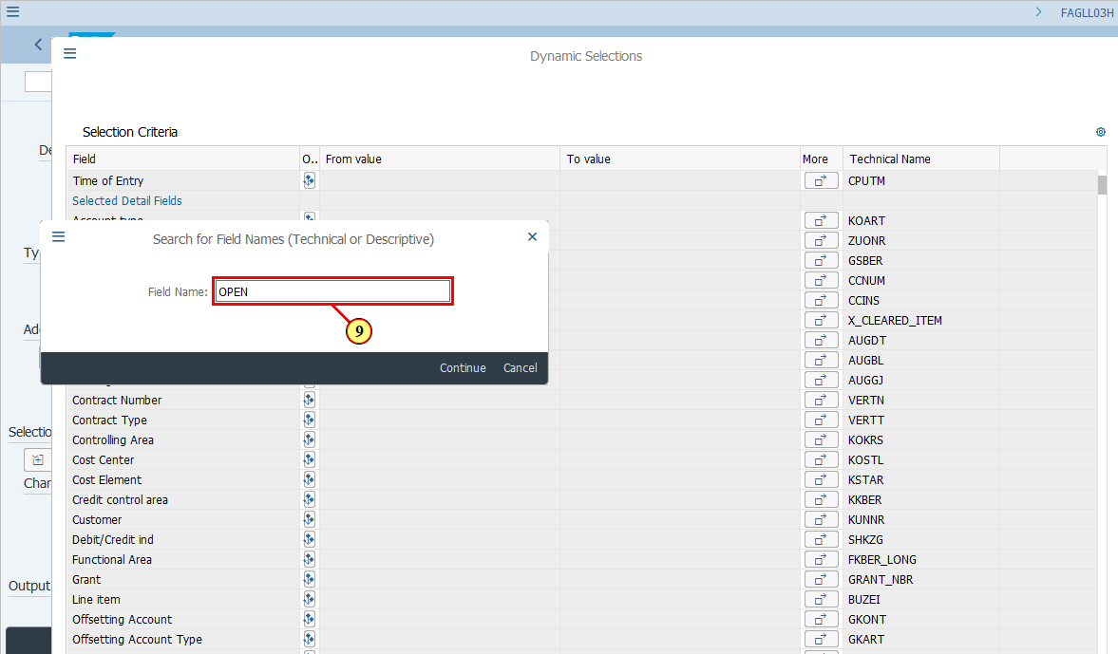
[10] Enter OPEN in the field.  In this example as there's already history of the values entered before, clicking the entry open item selects it. | 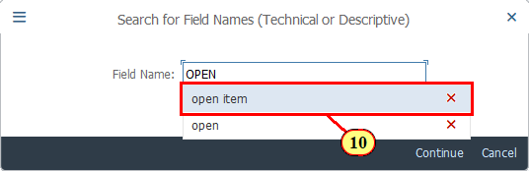
[11] Click Continue .  You can also press Enter. | 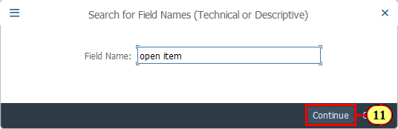
[12] Click next to field Open Item Management to open the dropdown list. | 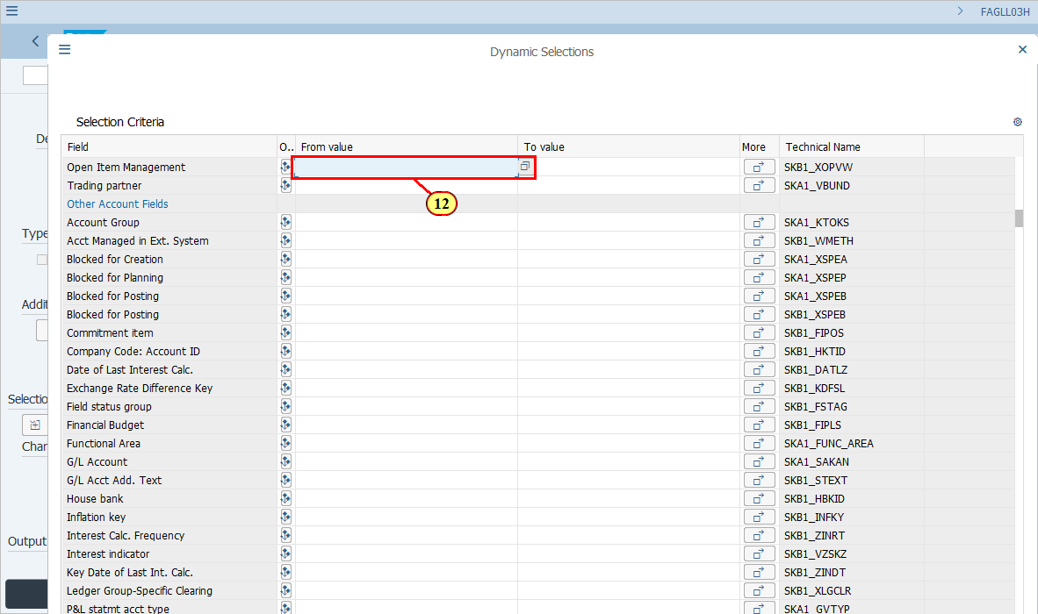
[13] Yes is double-clicked. | 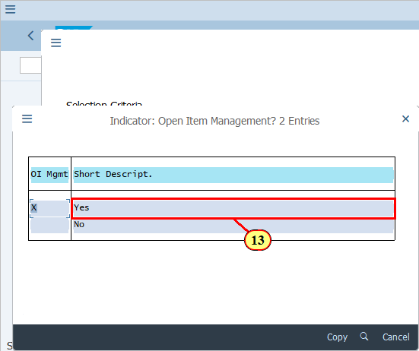
  Note that we now have One Restriction Active.  Now we will be seeing only the items for G/L accounts which are set up as Open Item Management in their G/L Master Data.  [14] Click Execute .  You can also press F8. | 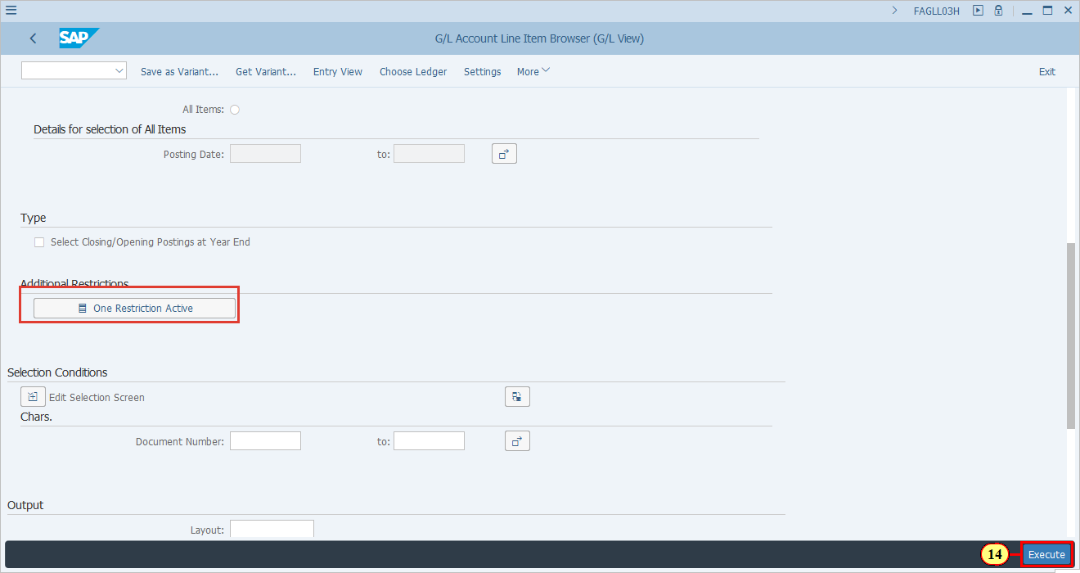
  If you already have a layout to see open items, choose it.  If you do not have a layout specific for open items, you can either choose a similar layout then change it, or change layout directly.  In this demonstration we will first select an existing layout then make some changes.  [15] Click Show/Hide Sidebar (F7) .  You can also press F7. | 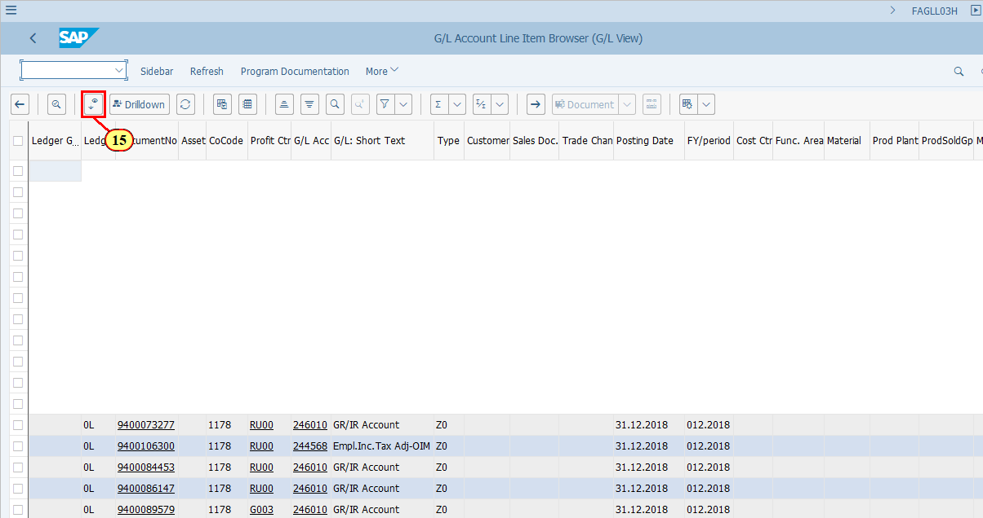
[16] Click Layout . | 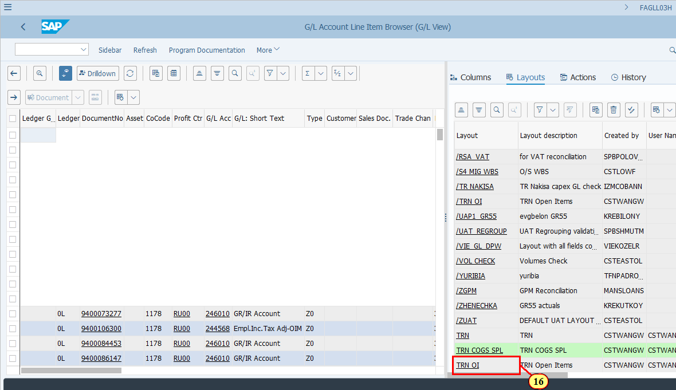
[17] Click Show/Hide Sidebar (F7) .  You can also press F7. | 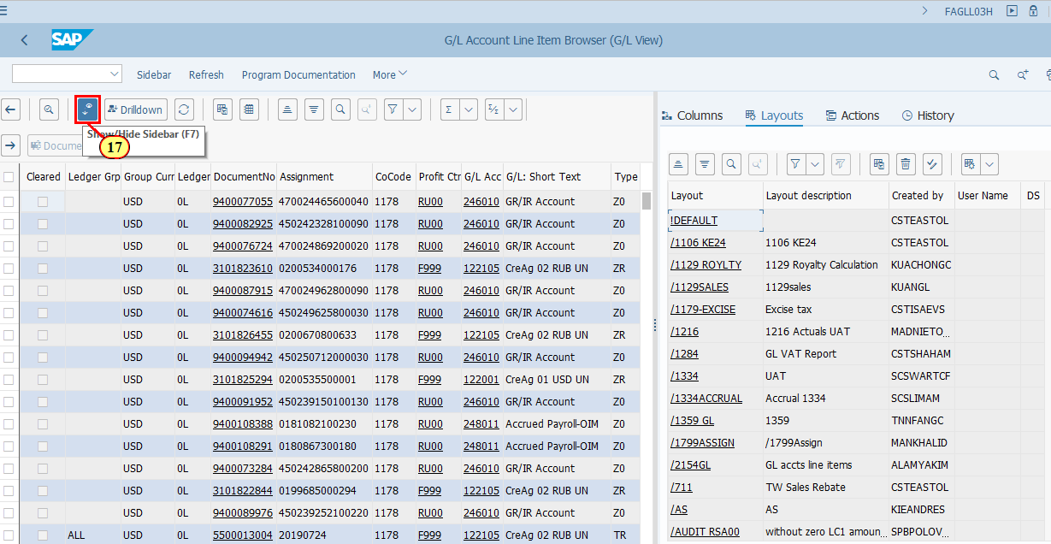
  You should have the highlighted columns in your layout to see which items are open/cleared in which ledger and ledger group.  [18] Click Change Layout... to add more fields. | 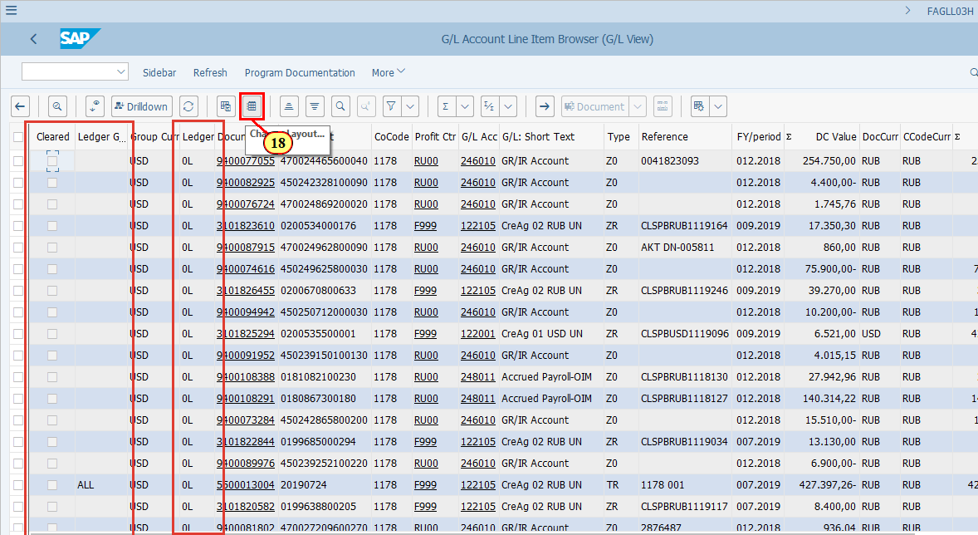
  You should have all the Amounts fields in your layout so that you can identify which open items can be cleared against each other.  [19] Click Transfer .  You can also press Enter. | 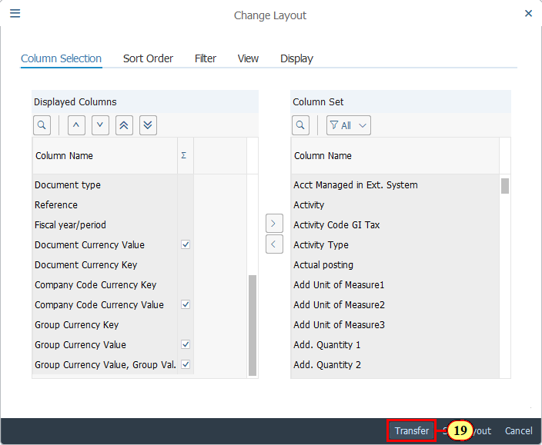
  You may want to sort the list by G/L account and Ledger or Ledger group, which will help you to identify the open items that may be cleared against each other.  [20] Click G/L Acc 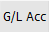. | 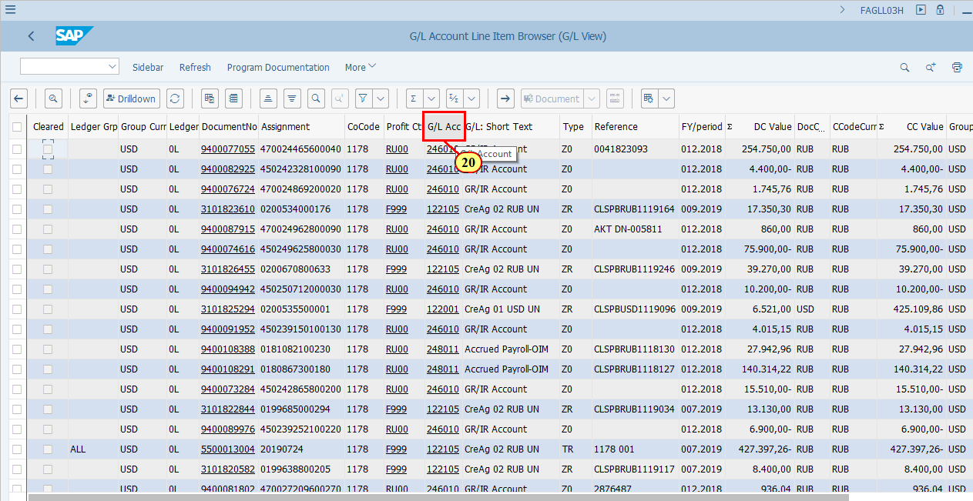
[21] Click Ledger Grp .  Press Ctrl key while performing the action. | 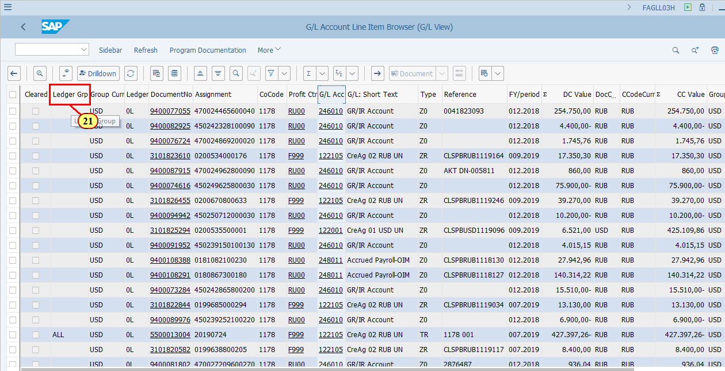
[22] Click Sort in Ascending Order . | 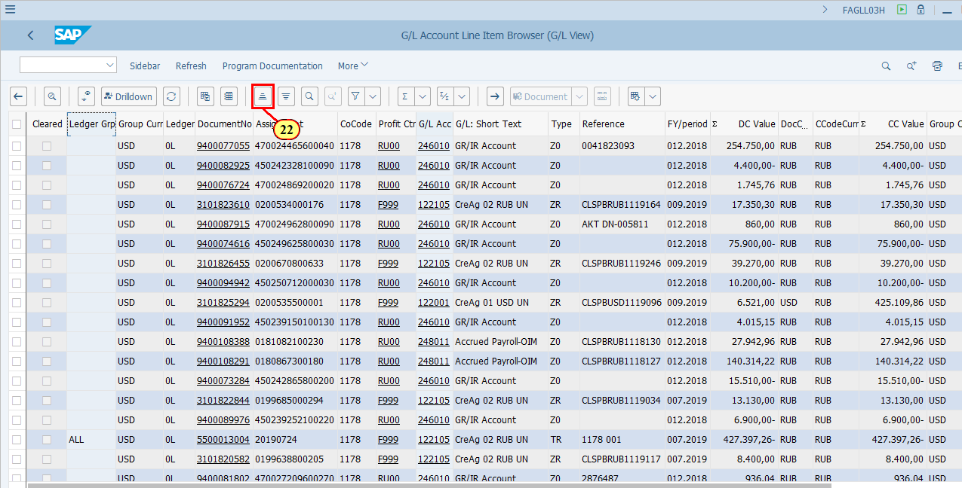
  If you have run your report with Cleared Items also selected, you may add a few columns to get a bit more details on clearing documents.  [23] Click Change Layout... . | 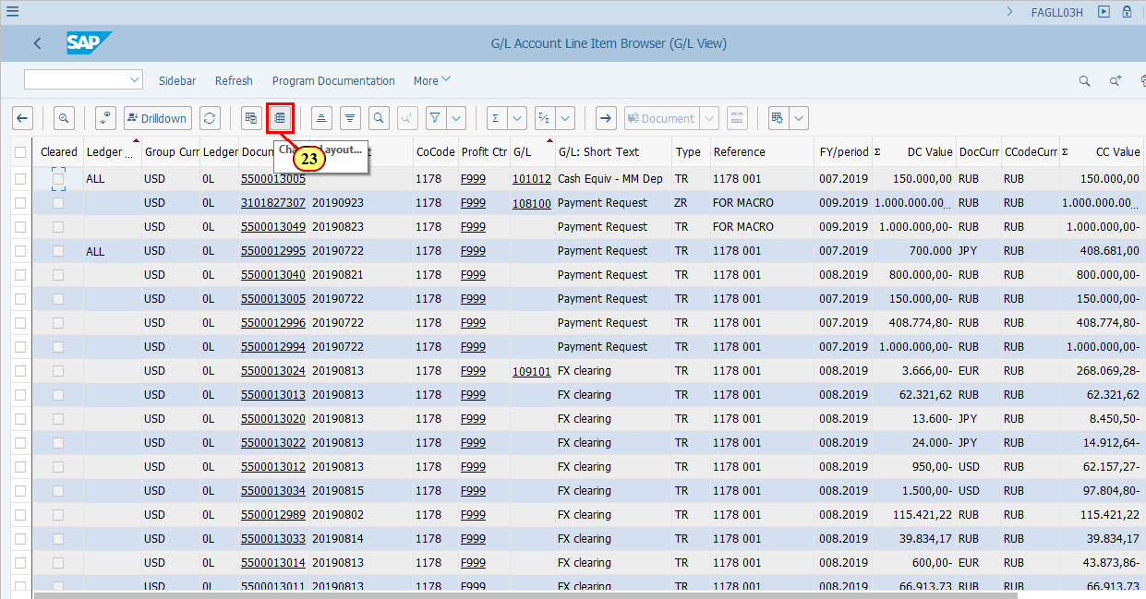
[24] Click Column Name . | 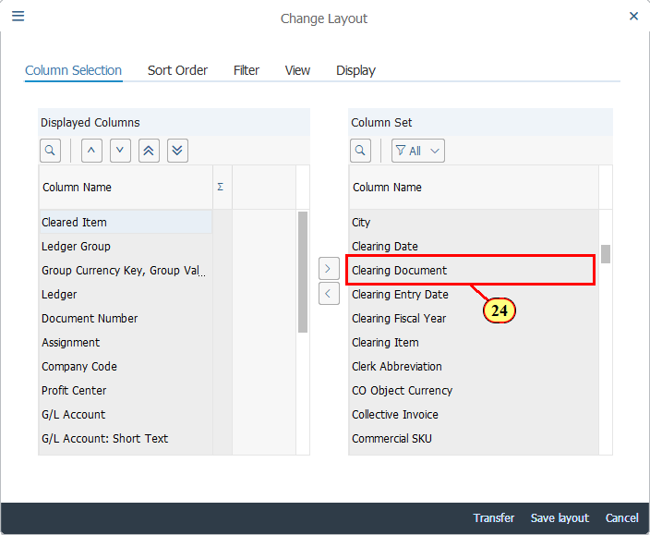
[25] Click Column Name .  Press Ctrl key while performing the action. | 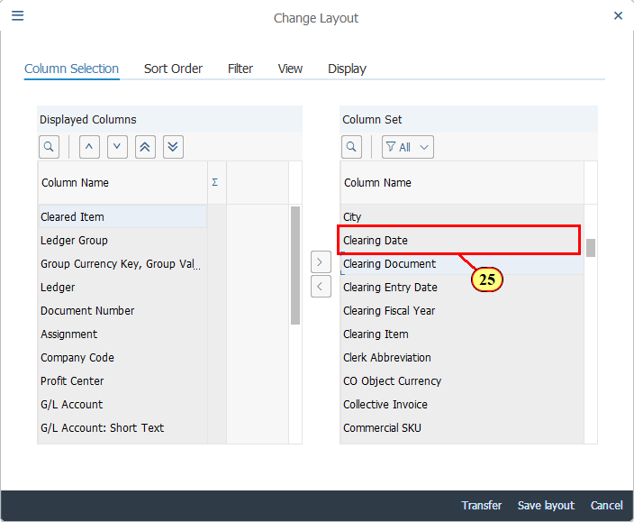
  These two fields, Clearing Date and Clearing Documents, provide details of when the items were cleared and by which document. You can sort or subtotal based on Clearing Document to see which items were cleared together via one Clearing Document.  Now we will cancel this and move to see examples of G/L line items for G/L accounts which are set as Clearing Specific to Ledger Groups.  [26] Click Cancel .  You can also press F12. | 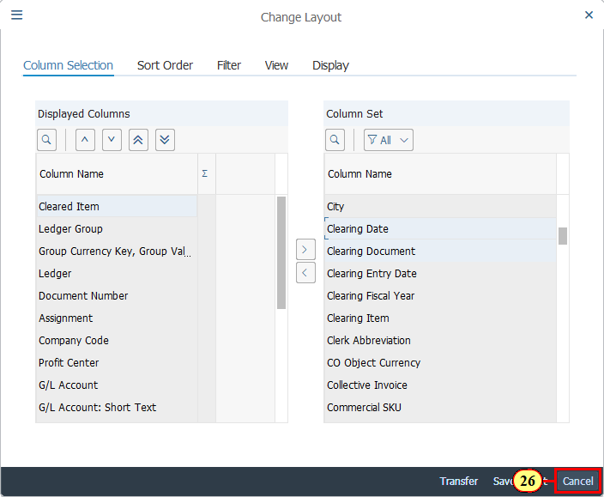
  Back on the FAGLL03H screen, we will use the Restriction function to restrict G/L accounts which have set up of Clearing Specific to Ledger Groups in their G/L Master Data.  [27] Click One Restriction Active . | 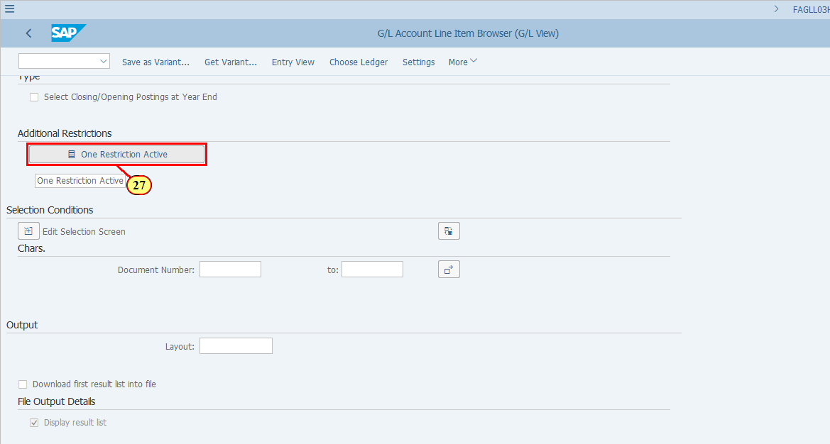
[28] First we need to clear the previous restriction field.  The From value field is cleared. | 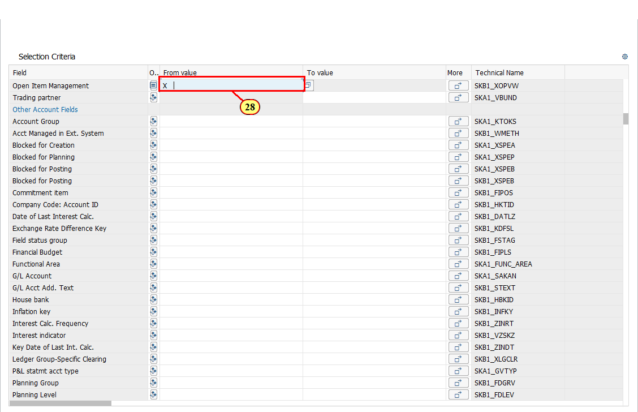
[29] Click the magifying glass icon to search again. | 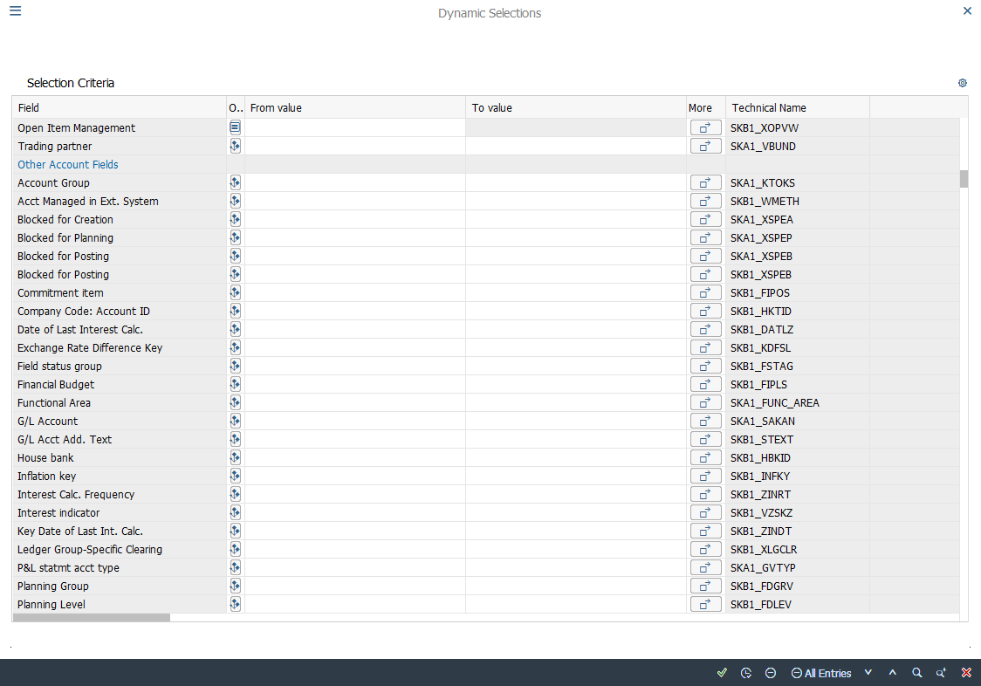
  In Search field box, enter the serach term.  [30] The Field Name field is filled out. | 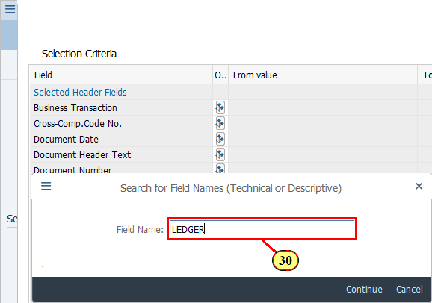
[31] Click next to field Ledger Group-Specific Clearing to open the dropdown list. | 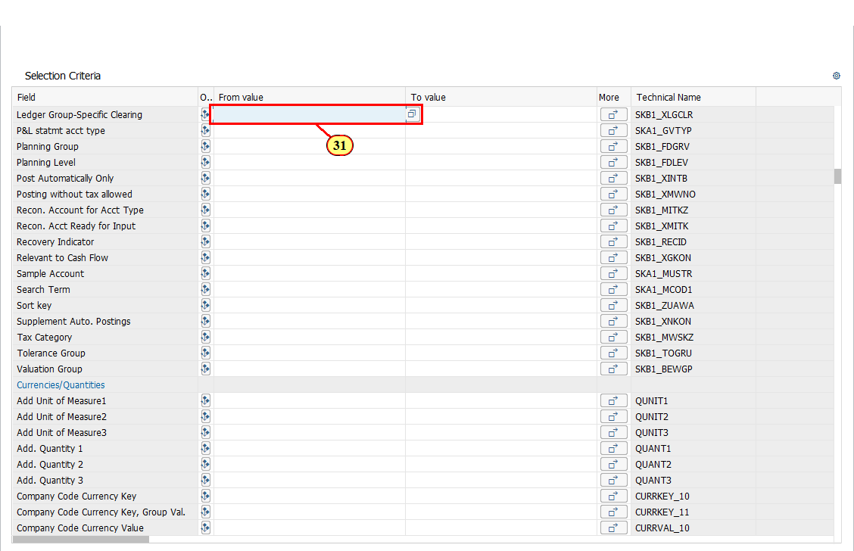
[32] X is double-clicked. | 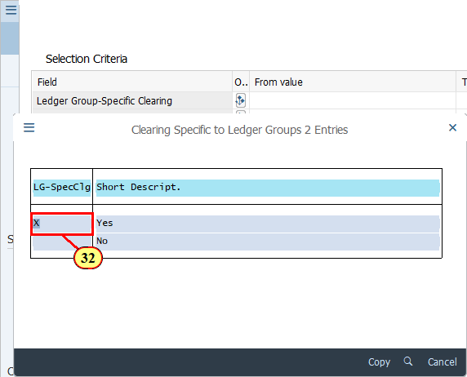
[33] Click Execute .  You can also press F8. | 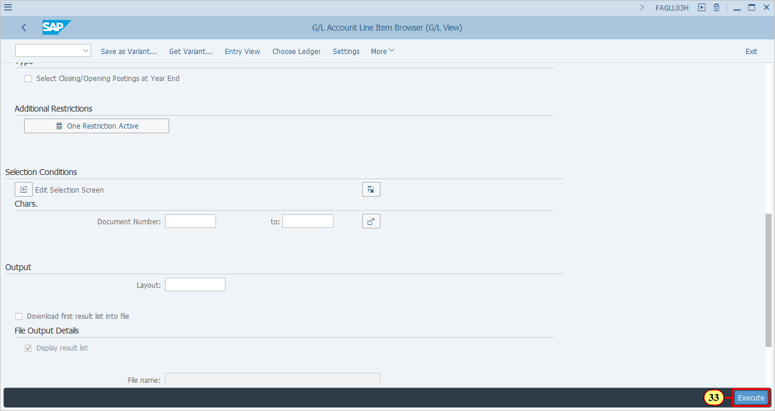
[34] Choose your saved layout for displaying Open Items.  Click Layout . | 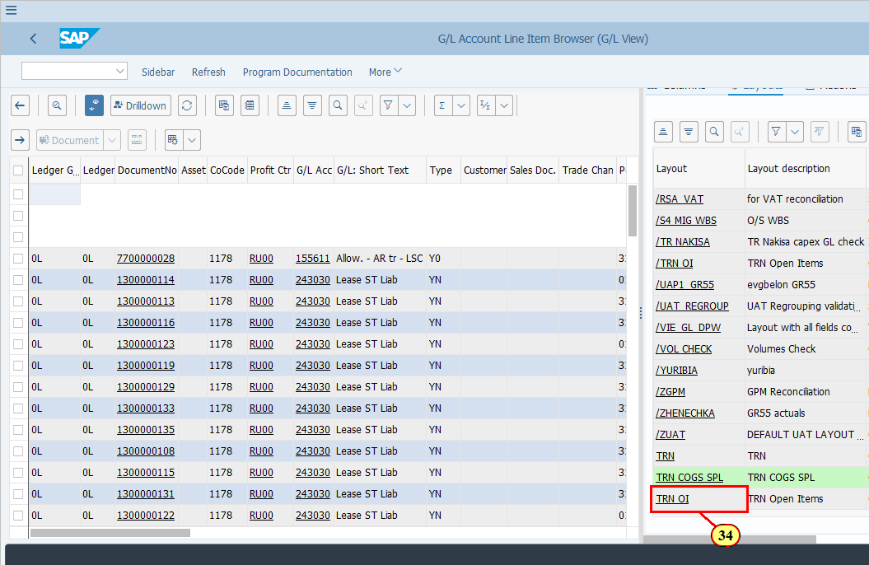
  Again, as we demonstrated before, sort your list by Ledger Group and G/L account to identify the items which can potentially be cleared.  [35] Click Ledger Grp . | 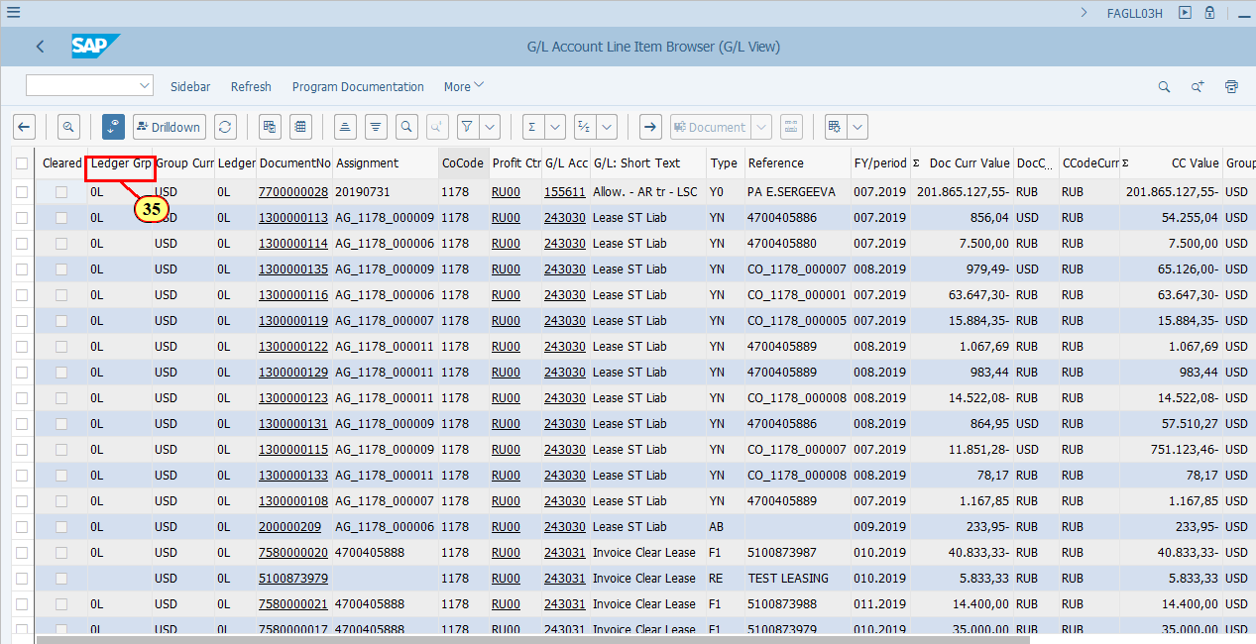
[36] Click G/L Acc .  Press Ctrl key while performing the action. | 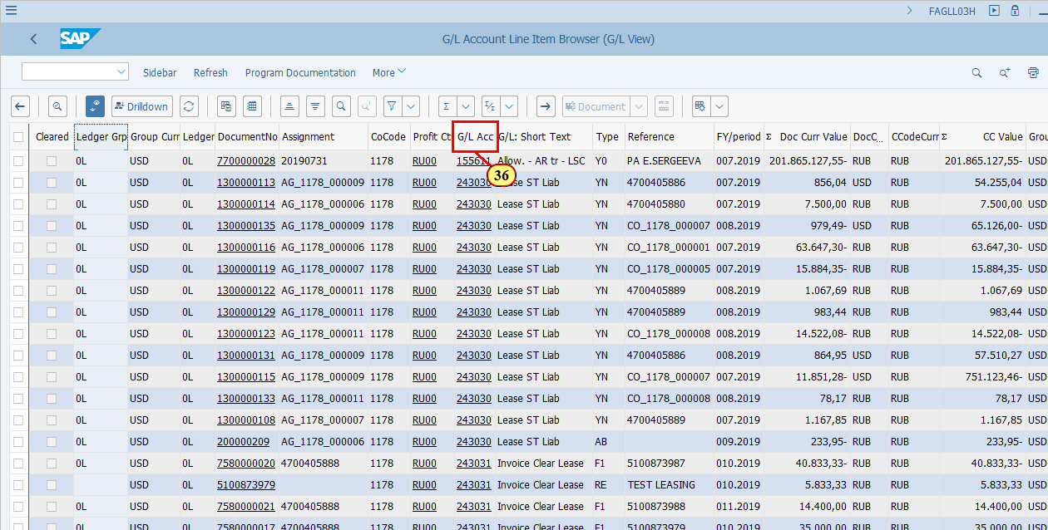
[37] Click Sort in Ascending Order . | 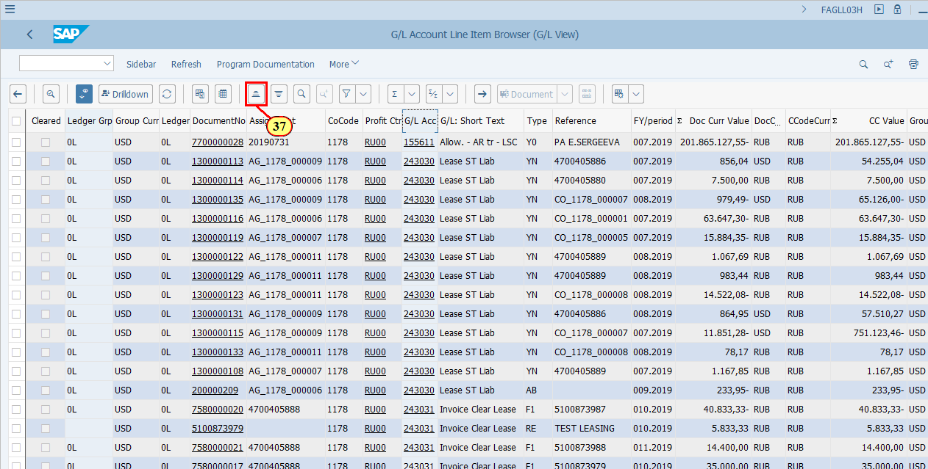
  Depending on the accounts, you may want to to subtotal by fields such as Reference, Assignment or Text, which may indicate the items are related to each other which helps to indentify which items may be cleared against each other.  For open items to be able to be cleared, they must add up to zero in one of the currencies (DC, LC1, LC2, LC3) within the same Ledger Group.. Detailed examples are available in Parallel Ledger training presentation. | 